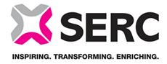
South Eastern Regional College Equality Screening Report
Period: 2021-22
Quarter 1: 1 November 2021 – 31 January 2022
Policy Title | Aim of Policy | New / Existing / revised policy | Date of Screening | Screening Decision
No policies screened |  |  |  | No adverse impact screened out

